NATIONAL HIRING METRICS
Data Collection Guide
For data analysts, HRIS teams, and ATS administrators
Version 1.1 · April 2026 · nationalhiringmetrics.org
This guide tells you everything your data team needs to collect, verify, and submit hiring data to calculate the nine National Hiring Metrics. Share it with your HRIS team, ATS administrator, Finance contact, and anyone else who holds the data described in this document.

1. Introduction
The National Hiring Metrics are nine independently ratified measures that create a common measurement language for UK recruitment. This guide is designed for the people who will collect the data — HRIS managers, ATS administrators, data analysts, and Finance contacts.

It covers:

- What each data point means and how to define it precisely
- Where to find each data point in your systems
- How the data points feed into the nine metric calculations
- How to enter your data into the National Hiring Metrics calculator

Important: the National Hiring Metrics use calendar days throughout, not working days.

1.1 Scope
Before collecting any data, confirm the scope with your Head of TA or Resourcing lead:

- Which part of the business is being benchmarked?
- What time period does the data cover — rolling 12 months, or a calendar year?
- Are TA-facilitated internal moves included? (they are by default)
- Are early careers hires included? (the standard covers experienced hire only by default)

All figures in a single submission must cover the same scope and time period. Mixing headcount from one division with vacancy data from another will produce unreliable results.

1.2 Where each data point comes from
System | Examples | Data collected
ATS | Pinpoint, Greenhouse, iCIMS, SmartRecruiters | Starters, declined offers, open vacancies, dates, sourcing channels, interview stages, salary offered
HRIS | Workday, SAP, Oracle HR, BambooHR | Employee headcount, first-year leavers
Finance | Management accounts, Finance team | Annual revenue, resourcing spend, provider costs, technology spend
HR Payroll | HR / Finance payroll system | TA team headcount cost, HR team TA-attributed costs

2. Data Point Definitions
Each data point is defined below. The definition tells you exactly what to count or measure, where to find it, and which metric it feeds.

2.1 Firm & Financial Data
Organisational headcount and all recruitment-related costs. Sourced from Finance and HRIS.

Source  HRIS  Format  Number  Feeds  Vacancy Ratio, Financial Impact | Employee Headcount (Permanent & FTC)  The most up-to-date number of employees on your payroll, covering the area of the business being benchmarked. Includes permanent and fixed-term contract (FTC) individuals. Excludes contractors and non-permanent individuals. This definition aligns with the Companies Act 2006, which requires companies to disclose the average number of persons employed under contracts of service during the financial year.
 | ⚠️ Use the figure as at the last day of the previous month. Should cover the same business scope as your vacancy data.

Source  Finance  Format  Currency (£)  Feeds  Financial Impact | Annual Revenue  The most up-to-date revenue figure as used by Finance, covering only the area of the business being benchmarked. Revenue is the total amount received for goods sold or services provided, calculated before expenses are subtracted. Where exact internal figures are sensitive, use the last published revenue figures from your annual report or Companies House filing — these are sufficient for the Financial Impact calculation.
 | ⚠️ Do not use budgeted revenue. Use the latest actuals from your Finance team or last published figures.

Source  Finance / HR budget  Format  Currency (£)  Feeds  Cost per Starter | HR & Resourcing-Held Spend  Total actual spend held by the HR or Resourcing function over the last 12 months. Includes agency fees, advertising costs, selection costs, and technology costs. Excludes headcount costs.
 | ⚠️ Use actual spend, not budget allocation.

Source  Finance / business unit  Format  Currency (£)  Feeds  Cost per Starter | Hiring Manager-Held Spend  Total actual recruitment spend held by the business or hiring managers outside the TA function. Includes agency fees and advertising costs held by business units.
 | ⚠️ Enter £0 if all spend sits with the TA function.

Source  IT / Finance  Format  Currency (£)  Feeds  Cost per Starter | Resourcing Technology Spend  Spend held elsewhere in the business on resourcing systems or technology — for example, ATS costs held by IT, or careers site development costs held outside the TA budget.
 | ⚠️ Enter £0 if all technology costs are already captured in HR & Resourcing-Held Spend.

Source  Finance / procurement  Format  Currency (£)  Feeds  Cost per Starter | RPO / Provider Cost  Total amount spent on an Exclusive Outsource or Hybrid RPO provider in the last 12 months. Includes both fixed and variable costs.
 | ⚠️ Enter £0 if your organisation does not use an RPO. Use actual spend, not contracted value.

Source  HR / Finance payroll  Format  Currency (£)  Feeds  Cost per Starter | TA Headcount Cost  Total salary and average bonus budget for the experienced hire TA team. Excludes RPO/hybrid provider employees and HR colleagues with a broader remit. Represent part-time roles proportionally.
 | ⚠️ Example: a recruiter on 0.5 FTE counts as 50% of their salary.

HR Team TA-Attributed Costs
If HR Advisers, Business Partners, or HR Managers spend time on TA activity, that time should be attributed to the cost of recruitment.

How to calculate each HR group cost: identify the total annual salary spend for that group, then multiply by the percentage of their collective time spent on TA activity. Example: three HR Advisers with a combined salary spend of £120,000, spending 20% of their time on TA = £24,000.

Before collecting these figures, check and confirm each of the following with your HR manager:

- Total number of HR Advisers involved in TA activity, even partially
- Their combined total salary spend (not individual salaries)
- The collective percentage of time they spend on TA versus other HR activity
- Repeat the above for Business Partners and Managers separately

If any group has no involvement in TA, enter £0 for that group — do not leave it blank.

Source  HR payroll + time allocation  Format  Currency (£)  Feeds  Cost per Starter | HR Adviser TA Cost  The TA-attributed salary cost of HR Advisers. Calculate as: total HR Adviser salary spend × percentage of collective time spent on TA.
 | ⚠️ Example: two advisers at £40,000 each, 25% time on TA = £20,000.

Source  HR payroll + time allocation  Format  Currency (£)  Feeds  Cost per Starter | HR Business Partner TA Cost  The TA-attributed salary cost of HR Business Partners. Calculate as: total HRBP salary spend × percentage of collective time spent on TA.
 | ⚠️ Enter £0 if Business Partners do not contribute to TA activity.

Source  HR payroll + time allocation  Format  Currency (£)  Feeds  Cost per Starter | HR Manager TA Cost  The TA-attributed salary cost of HR Managers. Calculate as: total HR Manager salary spend × percentage of collective time spent on TA.
 | ⚠️ Enter £0 if HR Managers do not contribute to TA activity.

2.2 Hiring Volume & Per-Hire Data
Hiring volume data is sourced from your ATS hired report. Per-hire data is collected at requisition level — one record per hire.

Source  ATS hired report  Format  Count  Feeds  Offer Acceptance Rate, Cost per Starter, First-Year Attrition, Sourcing Channel Effectiveness, Interview Ratio, Financial Impact | External Permanent & FTC Starters  Total number of external permanent and FTC hires who started in the 12 months prior to data entry. Excludes contractors, temps, and early careers hires.

Source  ATS  Format  Count  Feeds  Offer Acceptance Rate, Cost per Starter, First-Year Attrition, Sourcing Channel Effectiveness, Interview Ratio, Financial Impact | TA-Facilitated Internal Moves  Total number of internal moves made in the last 12 months where TA resource was actively involved. Excludes informal transfers and manager-led moves where TA played no role.

Source  ATS  Format  Count  Feeds  Offer Acceptance Rate | Number of Declined Offers  Total number of verbal and written offers declined by candidates in the last 12 months. A non-response is not counted as a declined offer.
Source  ATS  Format  Count  Feeds  Offer Acceptance Rate | ⚠️ Do not include offers where no response was received.

Source  ATS hiring report  Format  Count  Feeds  Vacancy Ratio | Open Vacancies — Current Month  Total number of active permanent vacancies formally authorised to recruit, as at the last day of the previous month. An open vacancy is any active vacancy where the candidate has not yet started.
 | ⚠️ Run this report on the last day of the previous month. Do not include vacancies on hold.

Source  ATS  Format  Date  Feeds  Time to Offer Accepted, Time to Start | Date Vacancy Formally Opens for Recruitment  The date on which TA was formally given authorisation to commence recruitment — the requisition open date, not the date the job was posted externally.
 | ⚠️ Confirm with your ATS team which field maps to authorisation date, not posting date. This is the most commonly mis-recorded data point.

Source  ATS  Format  Date  Feeds  Time to Offer Accepted | Offer Acceptance Date  The date on which the successful candidate formally accepted the offer of employment for this vacancy.
Source  ATS  Format  Date  Feeds  Time to Offer Accepted | ⚠️ Use the date of formal acceptance, not the date the offer was made.

Source  ATS / HRIS  Format  Date  Feeds  Time to Start | Candidate Start Date  The contracted first day of employment for the successful candidate.

Source  ATS  Format  Category  Feeds  Sourcing Channel Effectiveness | Sourcing Channel  The primary sourcing channel through which the successfully hired candidate was identified or applied. Standard categories: Direct / Careers site, Job board, LinkedIn, Agency, Internal referral, Headhunted, Other.
 | ⚠️ Agree channel categories before data collection begins.

Source  ATS  Format  Count  Feeds  Interview / Assessment-to-Offer Ratio (interim proxy) | Number of Interview Stages (current proxy)  Total number of interview or assessment stages the successfully hired candidate completed. Counts only stages conducted by or involving the hiring manager — screening calls handled solely by TA are excluded.
 | ⚠️ This is the current interim proxy for Metric 08. Total Candidates Interviewed at Hiring Manager Stage (added in V22) will replace this as the primary input once collected.

Source  ATS  Format  Count  Feeds  Interview / Assessment-to-Offer Ratio (Metric 08) | Total Candidates Interviewed at Hiring Manager Stage  Total number of candidates who completed at least one interview or assessment stage conducted by or involving the hiring manager for this requisition, regardless of outcome. Includes candidates interviewed but not offered the role. Excludes candidates screened solely by TA. Each unique candidate counts once per requisition.
 | ⚠️ New data point added in V22. Confirm with your ATS team whether this can be extracted from your hired report. If not available, use the Number of Interview Stages (proxy) until your ATS is configured to capture it.

Source  ATS / offer management  Format  Currency (£)  Feeds  Offer Acceptance Rate — segmentation | Salary Offered  The salary level of the offer made to the successful candidate. Used to segment Offer Acceptance Rate analysis by salary band.

2.3 Attrition Data
Attrition data requires cross-referencing your HRIS termination data with your ATS hired report.

Source  HR headcount report  Format  Count  Feeds  First-Year Attrition Rate | New Hires Leaving Within 12 Months  Total number of hires who left within 12 months of joining the business, including those leaving for redundancy and performance management reasons.
 | ⚠️ Cross-reference HRIS termination data against your ATS hired report to confirm these were new hires within scope.

3. The Nine Metrics
Each metric is shown below with its definition, formula, required data inputs, and a worked example.

Metric 01 Vacancy Ratio (%)
Definition | Open positions as a percentage of total employee headcount, as at the last day of the previous month.
Formula | (Open vacancies ÷ Employee headcount) × 100
Plain English | Divide your current open vacancies by your employee headcount, then multiply by 100.
Data inputs | Open vacancies (current month), Employee headcount (permanent & FTC)
Worked example | 45 open vacancies ÷ 2,000 headcount × 100 = 2.25%

Metric 02 Time to Offer Accepted (Days)
Definition | Average calendar days from vacancy formally opening for recruitment to the candidate formally accepting the offer.
Formula | Offer acceptance date − Requisition open date
Plain English | For each hire, subtract the date the vacancy opened from the date the offer was accepted. Average these across all hires.
Data inputs | Offer acceptance date, Date vacancy formally opens for recruitment
Worked example | 15 May offer accepted − 12 April vacancy opened = 33 days

Metric 03 Time to Start (Days)
Definition | Average calendar days from vacancy formally opening for recruitment to the candidate's first day of employment.
Formula | Candidate start date − Requisition open date
Plain English | For each hire, subtract the date the vacancy opened from the candidate's first day. Average these across all hires.
Data inputs | Candidate start date, Date vacancy formally opens for recruitment
Worked example | 1 July start date − 12 April vacancy opened = 80 days

Metric 04 Offer Acceptance Rate (%)
Definition | Percentage of job offers made that are accepted by candidates. Reported in total and by salary band.
Formula | Total starters ÷ (Total starters + Declined offers) × 100
Plain English | Divide the number of starters by the total number of offers made (starters plus declined offers), then multiply by 100.
Data inputs | External starters, Internal moves, Declined offers
Worked example | 138 starters ÷ (138 + 12 declined) × 100 = 92%

Metric 05 Cost per Starter (£)
Definition | Total recruitment function costs divided by total starters in the period.
Formula | Total recruitment costs ÷ Total starters
Plain English | Add together all recruitment costs (see data inputs). Divide by the total number of starters.
Data inputs | HR & resourcing spend, Hiring manager spend, Technology spend, RPO cost, TA headcount cost, HR team TA-attributed costs, External starters, Internal moves
Worked example | £950,000 total costs ÷ 138 starters = £6,884 per starter

Metric 06 First-Year Attrition Rate (%)
Definition | Percentage of new starters leaving voluntarily or involuntarily within 12 months of their start date.
Formula | Leavers within 12 months ÷ Total starters × 100
Plain English | Divide the number of leavers in their first 12 months by total starters. Multiply by 100.
Data inputs | New hires leaving within 12 months, External starters, Internal moves
Worked example | 22 leavers ÷ 138 starters × 100 = 15.9%

Metric 07 Sourcing Channel Effectiveness (%)
Definition | Percentage of starters generated from each defined sourcing channel.
Formula | Starters from each channel ÷ Total starters × 100
Plain English | For each channel, count how many of your starters came from that source. Divide by total starters and multiply by 100.
Data inputs | Sourcing channel per hire, External starters, Internal moves
Worked example | 42 LinkedIn starters ÷ 138 total × 100 = 30.4% from LinkedIn

Metric 08 Interview / Assessment-to-Offer Ratio (Ratio)
Definition | Total candidates interviewed at hiring manager stage divided by total offers made.
Formula | Total candidates interviewed at hiring manager stage ÷ Total offers made
Plain English | Count the total number of candidates put in front of a hiring manager across all requisitions. Divide by the total number of offers made.
Data inputs | Total candidates interviewed at hiring manager stage (V22), Total starters, Declined offers
Worked example | 420 candidates interviewed ÷ 150 offers = 2.8:1

Metric 09 Financial Impact of Making New Hires (£)
Definition | Total revenue value attributable to filled roles — the daily revenue value per employee multiplied by average time vacancies were open, across all starters.
Formula | Revenue per employee per day × Average time to offer accepted × Total starters
Plain English | Divide annual revenue by employee headcount and by 365 to get the daily revenue value per person. Multiply by average time to offer accepted, then by total starters. Employee headcount aligns with the Companies Act 2006 definition.
Data inputs | Annual revenue, Employee headcount (permanent & FTC), Average time to offer accepted, External starters, Internal moves
Worked example | £50m ÷ 2,150 headcount ÷ 365 days = £63.72/day × 33 days × 138 starters = £289,600

4. Step-by-Step Submission Guide
Once you have collected all the data points in Section 2, follow these steps to submit your data and generate your results.

Calculator: https://nationalhiringmetrics.org/calculator.html

Step 1 — Confirm scope and time period
- Which part of the business is included?
- What is the data period — rolling 12 months or calendar year?
- Are internal moves included?
- Are early careers hires excluded?

Record your agreed scope in writing before you start. If scope changes mid-collection you will need to start again.

Step 2 — Collect data from each system
- Run your ATS hired report for the agreed period. Extract starters, declined offers, dates, sourcing channels, and interview stages for all hires in scope.
- Run your ATS vacancy report. Extract open vacancies as at the last day of the previous month.
- Request employee headcount (permanent and FTC) from your HRIS team.
- Request annual revenue from Finance, covering the same scope as your hire data.
- Request recruitment spend breakdown from Finance and HR budget holders. Allow up to a week for this.
- Request HR team TA-attributed cost estimates from your HR manager.
- Run your HRIS termination report and cross-reference against your ATS hired report to identify first-year leavers.

The data most likely to cause delays is the cost data. Request this early, in parallel with your ATS extraction.

Step 3 — Validate your data
- Open vacancies should be lower than total headcount. If they exceed 10% of headcount, verify the vacancy figure.
- First-year leavers should be lower than total starters. If attrition exceeds 50%, verify the time period alignment.
- Declined offers should be a small fraction of starters. A ratio above 1:3 is unusually high.
- Cost per starter should fall between £2,000 and £20,000 for most UK employers.
- Average time to offer accepted should be between 14 and 90 days. Figures outside this range suggest a data mapping issue with the requisition open date.

Step 4 — Open the calculator
Navigate to: https://nationalhiringmetrics.org/calculator.html

Step 5 — Complete the three-step form

Step 1 of 3 — About you
Enter your name, email address, company, job title, and industry sector. Your results will be sent to your email address.

Step 2 of 3 — Your hiring data
Enter: employee headcount (permanent and FTC), annual revenue, open vacancies, external starters, internal moves, declined offers, first-year leavers, average time to offer accepted (days), average time to start (days), and average interview stages per hire.

For averages: calculate the figure for each individual hire in your ATS report, then take the mean across all hires in scope.

Step 3 of 3 — Your recruitment costs
Enter a single total recruitment spend figure. This should be the sum of all cost fields: HR and resourcing spend, hiring manager spend, technology spend, RPO costs, TA headcount cost, and any HR team TA-attributed costs.

Step 6 — Review your results
Your nine metric results are displayed immediately and saved to the National Hiring Metrics benchmark database. To access a full benchmarked comparison report, contact:

jeremy.thornton@talentbenchmarking.com | National Hiring Metrics — Benchmarking enquiry

5. Quick Reference Checklist
Share this table with each system owner and ask them to confirm the field name or report they will use for each data point.

Data Point | Source | Format | Feeds Metric(s)
Employee Headcount (Permanent & FTC) | HRIS | Number | Vacancy Ratio, Financial Impact
Annual Revenue | Finance | Currency (£) | Financial Impact
HR & Resourcing-Held Spend | Finance / HR budget | Currency (£) | Cost per Starter
Hiring Manager-Held Spend | Finance / business unit | Currency (£) | Cost per Starter
Resourcing Technology Spend | IT / Finance | Currency (£) | Cost per Starter
RPO / Provider Cost | Finance / procurement | Currency (£) | Cost per Starter
TA Headcount Cost | HR / Finance payroll | Currency (£) | Cost per Starter
HR Adviser TA Cost | HR payroll + time allocation | Currency (£) | Cost per Starter
HR Business Partner TA Cost | HR payroll + time allocation | Currency (£) | Cost per Starter
HR Manager TA Cost | HR payroll + time allocation | Currency (£) | Cost per Starter
External Permanent & FTC Starters | ATS hired report | Count | Offer Acceptance Rate +
TA-Facilitated Internal Moves | ATS | Count | Offer Acceptance Rate +
Number of Declined Offers | ATS | Count | Offer Acceptance Rate
Open Vacancies — Current Month | ATS hiring report | Count | Vacancy Ratio
Date Vacancy Formally Opens for Recruitment | ATS | Date | Time to Offer Accepted +
Offer Acceptance Date | ATS | Date | Time to Offer Accepted
Candidate Start Date | ATS / HRIS | Date | Time to Start
Sourcing Channel | ATS | Category | Sourcing Channel Effectiveness
Number of Interview Stages (current proxy) | ATS | Count | Interview Ratio (interim)
Total Candidates Interviewed at HM Stage | ATS | Count | Interview Ratio (V22)
Salary Offered | ATS / offer management | Currency (£) | Offer Acceptance Rate — segmentation
New Hires Leaving Within 12 Months | HR headcount report | Count | First-Year Attrition Rate

6. From Internal Data to Market Intelligence

Calculating your nine metrics is the starting point. The real value begins when your data is independently verified and placed in context against your peers.
Once you submit your data through the National Hiring Metrics calculator, you are measuring your performance against a fixed standard. That is valuable. What you cannot yet see is whether your 33-day time to offer accepted is fast or slow for your sector, or whether your £6,884 cost per starter is above or below what organisations like yours are spending.

That is what the Talent Benchmarking platform provides. For TA leaders, independently verified external benchmarks are a powerful tool in both directions: they give you the evidence to demonstrate where your function is genuinely outperforming the market, and they give you the precision to identify exactly where performance can be improved and by how much. Whether you are making the case for investment, defending a budget, or building a performance improvement plan, the platform gives you data your business cannot argue with.

Talent Benchmarking is the only independently verified, externally benchmarked platform built specifically to the National Hiring Metrics standard. It transforms your internal hiring data into external market intelligence — showing exactly where your TA function is leading, where it is lagging, and where investment will generate the greatest return.

6.1 What the benchmark adds

Without benchmarking  • You know your cost per starter is £6,884  • You know your time to offer is 33 days  • You know your attrition is 15%  • You cannot tell if any of this is good or bad | With the Talent Benchmarking platform  • £6,884 is upper quartile for your sector  • 33 days is below the sector average of 41 days  • 15% attrition is better than your peer average of 16.8%  • You know exactly where to focus and why

6.2 Sample dashboards
The examples below illustrate how your submitted data is presented in the platform. Each metric is shown as your actual result against independently verified sector benchmarks: Least in Class, Lower Quartile, Average, Upper Quartile, and Best in Class.

First-Year Attrition Rate
In this example, the organisation's actual attrition rate of 15.0% sits between the sector average (16.8%) and the upper quartile (14.3%), placing them in a strong but improvable position. The platform identifies this as a performance area where targeted action could move them into the upper quartile.

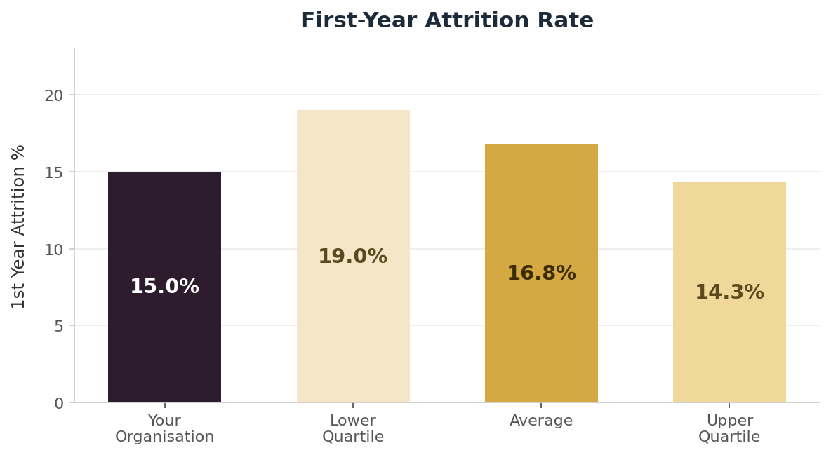

Financial Impact of Making New Hires
In this example, the organisation's financial impact of £4.3M from their hiring activity places them alongside the Least in Class benchmark — indicating that a significant proportion of potential revenue value is being lost to extended vacancy periods. Reducing average time to offer accepted by even 10 days would have an immediately measurable impact on this metric.

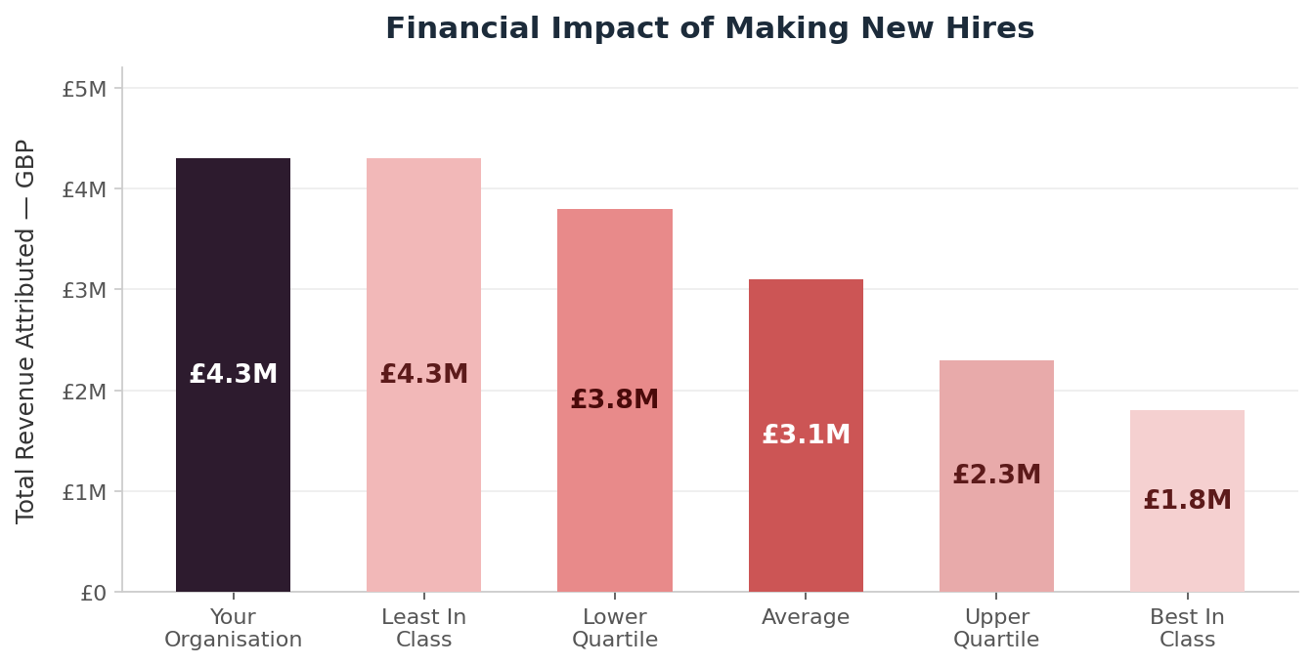

6.3 The full platform — 25+ dashboards
The National Hiring Metrics calculator gives you your nine headline measures. The Talent Benchmarking platform delivers full operational and strategic oversight across your entire TA function, with over 25 independently benchmarked dashboards organised into five sections.

Beyond the nine core metrics, the platform provides insight into areas that are difficult to evaluate without external comparison. Supplier performance is one of the most valuable: the platform benchmarks your cost per hire, attrition rate, and time to fill by source of hire — so you can see not just how much you are spending on LinkedIn, agency, or direct sourcing, but whether what you are getting back is above or below market. For many TA leaders this is the single most actionable output in the platform, enabling direct conversations with suppliers backed by independent data.

Example: your LinkedIn cost per hire is £3,200 against a sector average of £2,100. Your agency attrition rate is 22% against a best-in-class benchmark of 11%. Both are findings the platform surfaces automatically from your submitted data.

All UK employers can access independently verified benchmarking through Talent Benchmarking.

To join the benchmarking programme or request a platform demonstration, contact:
jeremy.thornton@talentbenchmarking.com | talentbenchmarking.com

National Hiring Metrics · nationalhiringmetrics.org · © 2026 Talent Benchmarking

